## Superstore Sales Analysis

## This report describes a study that analyzed data to find the best-performing products, regions, categories, and customer groups for Superstore. The goal is to help Superstore make more money and stand out from competitors by using the findings from the analysis.

## Introduction

## The changing nature of retail requires using data to be as efficient and profitable as possible. Having organized data and knowledgeable people to understand it well is very important for success. This study will use different tools – Excel to look at the data first, SQL to analyze it deeply, and Tableau to present the data visually – to find important information from Superstore's sales data

## Executive Summary

## In today's competitive retail environment, it's crucial to interpret data clearly to succeed. This project focuses on analyzing sales data from Superstore to discover important trends and patterns. These insights will help:

## Identify Profitable Products & Categories: Determine which products and categories bring in the most profit. This information guides targeted marketing efforts and where to allocate resources effectively.

## Recognize High-Performing Regions & Customer Segments: Pinpoint the regions and customer groups that contribute the most to profits. This allows for customized strategies to enhance sales and satisfy customers better.

## Track Emerging Trends: Monitor sales patterns over different time periods to anticipate future demand and improve inventory management. Understanding these trends helps in making informed business decisions

## Dataset

## The data is publicly available through Kaggle under <https://www.kaggle.com/datasets/vivek468/superstore-dataset-final>.

## It comes with 9995 rows with 9994 being pure data and the other one row being the column headers. It contains data recorded between the 3rd of January 2014 (the first order date) to the 5th of January 2018 (the last shipping date). (The last order date is the 30th of December 2017, so we will instead use the order dates range to represent our 4 years of business)

## It contains the data of 793 customers.

## The data contains the 21 columns namely; Row ID, Order ID, Order Date, Ship Date, Ship Mode, Customer ID , Customer Name, Segment, Postal Code, City, State, Country, Region, Product ID, Category, Sub-Category, Product Name, Sales, Quantity, Discount and Profit

## The only limitations of our dataset that I could mention is that the most recent data point was almost 6 years ago. So our data is not current. However, our data is quite reliable, original, comprehensive and is cited.

## Sales and Profit Analysis by Quarter (2014-2017)

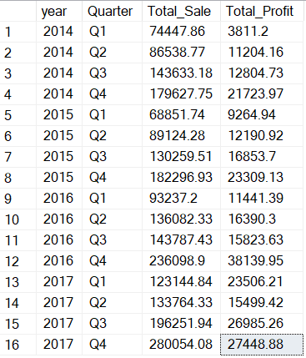

**Observations:**

Over the span of four years, sales numbers went up and down, meaning they varied. Some parts of the year saw more sales than others. For instance, in the last quarter of 2017, sales reached their peak at $280,054.08. Likewise, profits changed from one quarter to another. Just like sales, the last quarter of 2017 had the highest profit, amounting to $27,448.88.

## Sales and Profit Analysis for Year 2014-2017

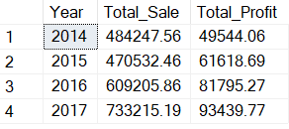

**Observations:**

Over the span of four years, sales consistently went up, reaching their peak in 2017 at $733,215.19. This marks a 51% increase from the sales in 2014. Similarly, profitability showed a continuous rise, hitting its highest point of $93,439.77 in 2017, indicating an 88% growth since 2014.

## Sales and Profit Analysis by Region

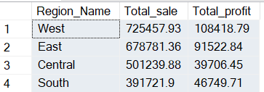

**Observations:**

The Western region shows the highest figures in both overall sales and profits, highlighting its substantial impact on the company's overall success. Moreover, there is a notable difference in sales and profits between the Western region and the other three regions.

## Highest Sales and Profit Analysis by State

## 

**Observations:**

* California has the highest total sales and total profits. Its total sales amount to $457,687.68, and its total profit is $76,381.60.
* New York comes next in total profit, with $74,038.64, although its total sales are lower than California's. This suggests that New York has a higher profit margin.
* States such as Indiana, Minnesota, and Delaware have the highest profit margins, surpassing 30%. However, their overall sales are not as high as California and New York.

## Lowest Sales and Profit Analysis by State

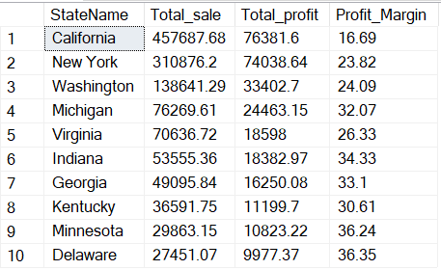

**Observations:**

Oregon has the smallest overall sales, amounting to $17,431.14.

• Texas has the least total profits, with -$25,729.29, signifying a loss rather than a gain.

• Colorado exhibits the lowest profit margin, standing at -20.33%. This implies that for each sale made, they incur more losses compared to other states.

## Highest Sales and Profit Analysis by City

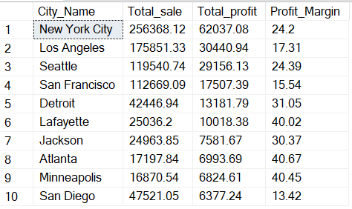

**Observations:**

* New York City generates the highest total sales at $256,368.12.
* New York City also achieves the highest total profit at $62,037.08.

While New York City leads in both total sales and total profit, Detroit boasts the highest profit margin at 31.05%. This indicates that Detroit generates a higher profit relative to its sales compared to other cities. Here's a breakdown of cities with the highest profit margins:

## Sales and Profit Analysis by TOP 10 City

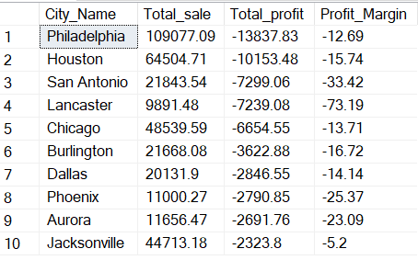

**Observations:**

* **Profitability:** Eight out of ten cities show negative total profits, indicating a net loss. Lancaster has the lowest total sales and the worst profit margin at -73.19%. San Antonio and Phoenix follow closely with significant negative profit margins.
* **Profitable Cities:** Jacksonville is the only city with a positive profit margin, indicating overall profitability. Chicago comes in second with a negative margin of only -13.71%

## Sales and Discount Analysis by Category

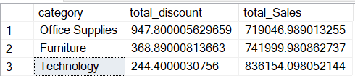

**Observations:**

* Office Supplies has the highest total discount amount at $947.80, but also the highest total sales at $719,046.99.
* Technology has the lowest total discount amount ($244.40) and the second-highest total sales ($836,154.10).
* When compared to total sales, all three categories have relatively low discount percentages. Office Supplies has the highest discount percentage (0.13%), followed by Furniture (0.05%) and Technology (0.03%).

**Category Sales and Profit Analysis**

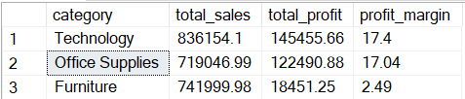

**Observations:**

* **Total Sales:** Technology leads in total sales with a significant margin at $836,154.10, followed by Office Supplies at $719,046.99 and Furniture at $741,999.98.
* **Total Profit:** Despite having the highest total sales, Technology generates the highest total profit at $145,455.66. Office Supplies follows closely at $122,490.88, while Furniture lags behind with $18,451.25.
* **Profit Margin:** Although Technology boasts the highest total sales and profit, Office Supplies hold a slightly higher profit margin at 17.04% compared to Technology's 17.4%. Furniture has the lowest profit margin at 2.49%.

## Sales and Profit Analysis by Region

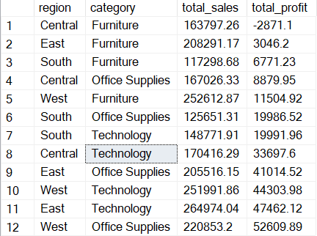

**Observation**

In the West region, Furniture generates the highest total sales ($252,612.87), while Office Supplies generates the highest total profit ($52,609.89).

In the Central and East regions, Technology generates the highest total sales and total profits.

In the South region, Technology generates the highest total sales ($148,771.91), while Office Supplies generates the highest total profit ($19,986.52).

## Sales and Profit by Top Category in Each State

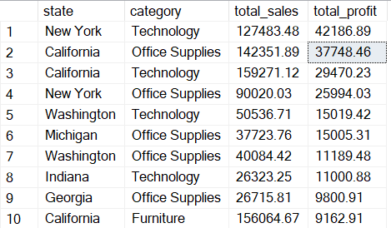

**Observations:**

* Technology is the top category for sales in California and New York, while Office Supplies is the top category for Georgia, Michigan, and Washington.
* This suggests that the demand for certain categories may vary depending on the state.

## Lowest Sales and Profit Analysis by State

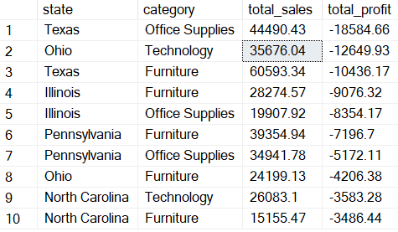

**Observations:**

* **Office Supplies:** Interestingly, Office Supplies is the lowest sales and profit category in two states (Illinois and Texas). This could indicate lower demand for office supplies in these regions or potentially suggest pricing or competition issues.
* **Furniture:** Furniture shows up as the lowest sales and profit category in North Carolina and Ohio
* **Technology:** While not the lowest in any state, Technology has the second-lowest profitability overall. It might be worthwhile to examine the cost structure and profit margins associated with technology products

## Top 10 Most Profitable Products

This table summerize the top 10 products that generate the highest total profit out of 1850 products

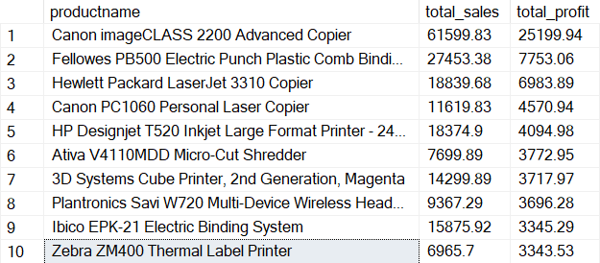

## Bottom 10 lowest Profitable Products

This table summerize the bottom 10 products that generate the lowest total profit out of 1850 products

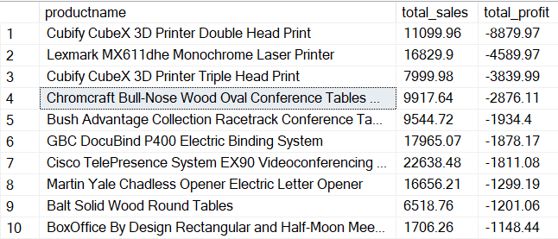

## Profit and Sales by Segment

This table summerize the segment that generate the highest total profit

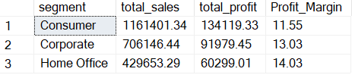

The Consumer segment generates the most profit at $$134,119.33. It's worth noting that the Home Office segment has the highest profit margin at 14.03%.

While the Consumer segment contributes the most profit to the company, the Home Office segment demonstrates the greatest efficiency in converting sales into profit, as indicated by its higher profit margin. This suggests that the company might benefit from further analyzing what products or services are driving sales within the Home Office segment and exploring potential strategies to replicate that success in other segments.

**Customer Count Analysis**

This Table summarizes the results of a query that identified the total number of unique customer IDs within the dataset.



**Observations:**

* This finding indicates that the company has a customer base of at least 793 distinct customers

**By Region:**

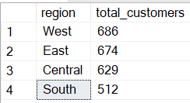

**Observations:**

* The data reveals a relatively even distribution of customers across the West, East, and Central regions, with customer counts ranging from 629 to 686.
* The South region has a slightly lower number of customers at 512.

**By State:**

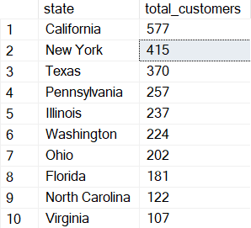

**Observations:**

* California has the highest number of customers with 577, followed by New York with 415.
* Texas ranks third with 370 customers.
* The remaining states (Pennsylvania, Illinois, Washington, Ohio, Florida, North Carolina, and Virginia) have varying numbers of customers, ranging from 107 to 257.

## Customer Rewards Program Analysis - Sales and Profit Performance

This table analyzes customer sales and profit data within the company's rewards program. The data includes five customer IDs out of 793, their total sales, and total profits generated.

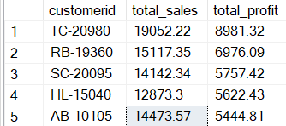

**Observations:**

* Customer TC-20980 emerges as the top spender within the rewards program, generating a total of $19,052.22 in sales. This customer also contributed the highest total profit of $8,981.32.
* The remaining customers on the list (RB-19360, SC-20095, HL-15040, and AB-10105) exhibit a relatively close range in total sales, ranging from $12,873.30 to $15,117.35. Their profit contributions also fall within a similar band.